Name: Talha Abdullah Bangyal
Roll number: 22F-3194
Section: BAI-3A
Lab: 11
----------------------------------------------------------------------------
Task 1
Problem
#include <iostream>
#include <string>

using namespace std;
struct Node {
string word;
Node* left;
Node* right;
int height;
Node(const string& w) : word(w), left(nullptr), right(nullptr), height(1) {}
};
class AVLTree {
private:
Node* root;

int max(int a, int b) {
if (a > b) {
return a;
}
else {
return b;
}
}

int height(Node* node) {
if (node == nullptr) {
return 0;
}
return node->height;
}

int balanceFactor(Node* node) {
if (node == nullptr) {
return 0;
}
return height(node->left) - height(node->right);
}

void updateHeight(Node* node) {
if (node) {
node->height = 1 + max(height(node->left), height(node->right));
}
}

Node* rightRotate(Node* y) {
Node* x = y->left;
Node* temp = x->right;
x->right = y;
y->left = temp;
updateHeight(y);
updateHeight(x);
return x;
}
Node* leftRotate(Node* x) {
Node* y = x->right;
Node* temp = y->left;
y->left = x;
x->right = temp;
updateHeight(x);
updateHeight(y);
return y;
}

Node* insert(Node* node, const string& word) {
if (!node)
return new Node(word);
if (word < node->word) {
node->left = insert(node->left, word);
}
else if (word > node->word) {
node->right = insert(node->right, word);
}
else {
return node;
}

updateHeight(node);
int balance = balanceFactor(node);
if (balance > 1 && word < node->left->word) {
return rightRotate(node);
}
if (balance < -1 && word > node->right->word) {
return leftRotate(node);
}
if (balance > 1 && word > node->left->word) {
node->left = leftRotate(node->left);
return rightRotate(node);
}
if (balance < -1 && word < node->right->word) {
node->right = rightRotate(node->right);
return leftRotate(node);
}
return node;
}

Node* minValueNode(Node* node) {
Node* current = node;
while (current->left != nullptr) {
current = current->left;
}
return current;
}

Node* deleteNode(Node* root, const string& word) {
if (!root) return root;

if (word < root->word) {
root->left = deleteNode(root->left, word);
}
else if (word > root->word) {
root->right = deleteNode(root->right, word);
}
else {
if (!root->left) {
Node* temp = root->right;
delete root;
return temp;
}
else if (!root->right) {
Node* temp = root->left;
delete root;
return temp;
}
Node* temp = minValueNode(root->right);
root->word = temp->word;
root->right = deleteNode(root->right, temp->word);
}
if (!root) return root;
updateHeight(root);
int balance = balanceFactor(root);
if (balance > 1 && balanceFactor(root->left) >= 0) {
return rightRotate(root);
}
if (balance > 1 && balanceFactor(root->left) < 0) {
root->left = leftRotate(root->left);
return rightRotate(root);
}
if (balance < -1 && balanceFactor(root->right) <= 0) {
return leftRotate(root);
}
if (balance < -1 && balanceFactor(root->right) > 0) {
root->right = rightRotate(root->right);
return leftRotate(root);
}

return root;
}

void inOrder(Node* node) {
if (node) {
inOrder(node->left);
cout << node->word << " ";
inOrder(node->right);
}
}

bool search(Node* node, const string& word) {
if (!node)
return false;
if (word == node->word)
return true;
if (word < node->word)
return search(node->left, word);
return search(node->right, word);
}

public:
AVLTree() : root(nullptr) {}

void insert(const string& word) {
root = insert(root, word);
}

void deleteWord(const string& word) {
root = deleteNode(root, word);
}

bool search(const string& word) {
return search(root, word);
}

void display() {
inOrder(root);
cout << endl;
}
};
void displayMenu() {
cout << "--- AVL Tree Dictionary ---" << endl;
cout << "1. Insert a word" << endl;
cout << "2. Search for a word" << endl;
cout << "3. Delete a word" << endl;
cout << "4. Display sorted dictionary" << endl;
cout << "0. Exit" << endl;
cout << "Choose an option (0-4): ";
}

int main() {
AVLTree tree;
string word;
int opt;
string words[] = { "apple", "banana", "cat", "dog", "elephant", "lion", "hippo", "zebra", "cherry", "lemon", "blueberry" };
for (const auto& w : words) {
tree.insert(w);
}
while (true) {
displayMenu();
cin >> opt;

switch (opt) {
case 1:
cout << "Write a word to insert: ";
cin >> word;
tree.insert(word);
cout << word << " is inserted." << endl;
break;

case 2:
cout << "Write a word to search: ";
cin >> word;
if (tree.search(word)) {
cout << word << " is found in dictionary." << endl;
}
else {
cout << word << " is not found in dictionary." << endl;
}
break;

case 3:
cout << "Write a word to delete: ";
cin >> word;
tree.deleteWord(word);
cout << word << " is deleted." << endl;
break;

case 4:
cout << "Sorted dictionary (in-order): ";
tree.display();
break;

case 0:
cout << "Exiting the program." << endl;
return 0;

default:
cout << "Invalid option. Please try again." << endl;
break;
}
}
system("pause");
return 0;
}
Screenshot

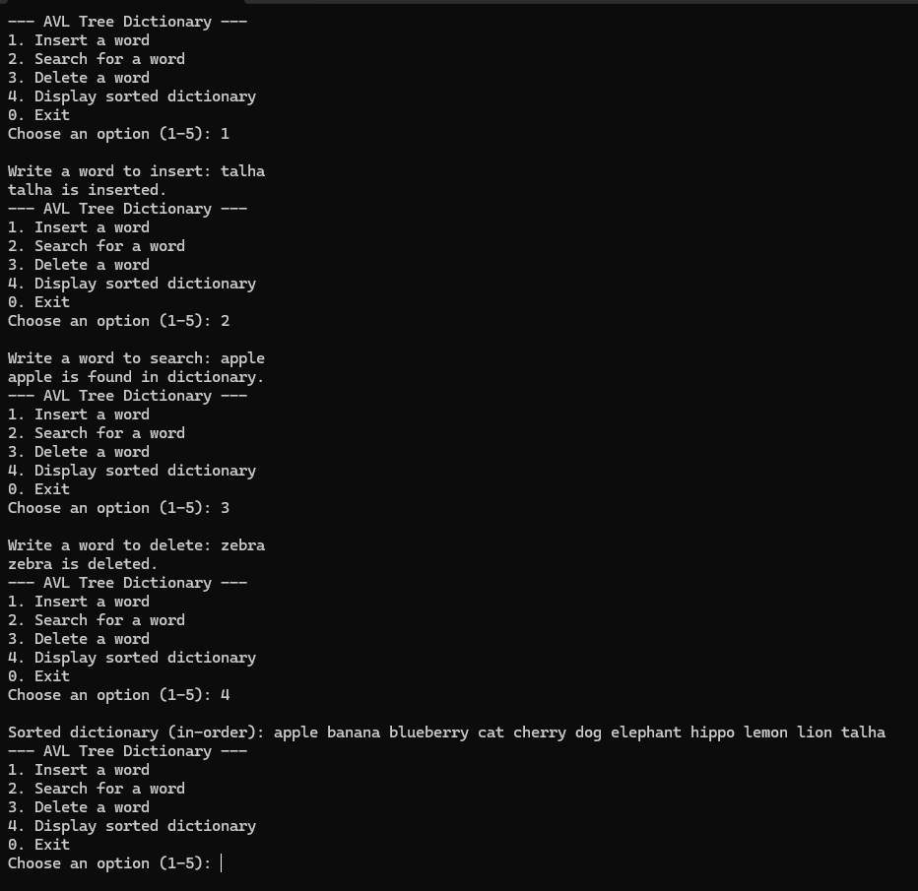
Task 2
Problem
#include <iostream>
using namespace std;

struct Node {
int value;
Node* left;
Node* right;
int height;

Node(int val) : value(val), left(nullptr), right(nullptr), height(1) {}
};

int max(int a, int b) {
if (a > b) {
return a;
}
else {
return b;
}
}
int height(Node* node) {
if (node == nullptr) {
return 0;
}
return node->height;
}

int balanceFactor(Node* node) {
if (node == nullptr) {
return 0;
}
return height(node->left) - height(node->right);
}

void updateHeight(Node* node) {
if (node) {
node->height = 1 + max(height(node->left), height(node->right));
}
}

Node* rightRotate(Node* y) {
Node* x = y->left;
Node* temp = x->right;
x->right = y;
y->left = temp;
updateHeight(y);
updateHeight(x);
return x;
}

Node* leftRotate(Node* x) {
Node* y = x->right;
Node* temp = y->left;
y->left = x;
x->right = temp;
updateHeight(x);
updateHeight(y);
return y;
}

Node* insert(Node* node, int value) {
if (!node) return new Node(value);
if (value < node->value) {
node->left = insert(node->left, value);
}
else if (value > node->value) {
node->right = insert(node->right, value);
}
else {
return node;
}
updateHeight(node);
int balance = balanceFactor(node);
if (balance > 1 && value < node->left->value) {
return rightRotate(node);
}
if (balance < -1 && value > node->right->value) {
return leftRotate(node);
}
if (balance > 1 && value > node->left->value) {
node->left = leftRotate(node->left);
return rightRotate(node);
}
if (balance < -1 && value < node->right->value) {
node->right = rightRotate(node->right);
return leftRotate(node);
}

return node;
}

Node* BSTtoAVL(Node* bstRoot) {
if (!bstRoot) return nullptr;
Node* avlRoot = new Node(bstRoot->value);
avlRoot->left = BSTtoAVL(bstRoot->left);
avlRoot->right = BSTtoAVL(bstRoot->right);
updateHeight(avlRoot);
int balance = balanceFactor(avlRoot);
if (balance > 1 && balanceFactor(avlRoot->left) >= 0) {
return rightRotate(avlRoot);
}
if (balance < -1 && balanceFactor(avlRoot->right) <= 0) {
return leftRotate(avlRoot);
}
if (balance > 1 && balanceFactor(avlRoot->left) < 0) {
avlRoot->left = leftRotate(avlRoot->left);
return rightRotate(avlRoot);
}
if (balance < -1 && balanceFactor(avlRoot->right) > 0) {
avlRoot->right = rightRotate(avlRoot->right);
return leftRotate(avlRoot);
}
return avlRoot;
}

bool hasPathSum(Node* root, int sum, int X) {
if (!root)
return false;
sum += root->value;
if (!root->left && !root->right) {
return sum > X;
}
return hasPathSum(root->left, sum, X) || hasPathSum(root->right, sum, X);
}

Node* swapSubtrees(Node* root) {
if (!root) return nullptr;
swap(root->left, root->right);
updateHeight(root);
int balance = balanceFactor(root);
if (balance > 1 && balanceFactor(root->left) >= 0) {
return rightRotate(root);
}
if (balance < -1 && balanceFactor(root->right) <= 0) {
return leftRotate(root);
}
if (balance > 1 && balanceFactor(root->left) < 0) {
root->left = leftRotate(root->left);
return rightRotate(root);
}
if (balance < -1 && balanceFactor(root->right) > 0) {
root->right = rightRotate(root->right);
return leftRotate(root);
}
return root;
}

void printInOrder(Node* node) {
if (!node) return;
printInOrder(node->left);
cout << node->value << " ";
printInOrder(node->right);
}

void displayMenu() {
cout << "--- BST-AVL Tree ---" << endl;
cout << "1. Insert " << endl;
cout << "2. Convert BST-AVL" << endl;
cout << "3. Display the BST-AVL" << endl;
cout << "4. Sum Target" << endl;
cout << "5. Swap sub Tree" << endl;
cout << "0. Exit" << endl;
}

int main() {
Node* bstRoot = nullptr;
Node* avlRoot = nullptr;
int choice, value;

while (true) {
displayMenu();
cout << "Choose an option (0-5): ";
cin >> choice;

switch (choice) {
case 1:
cout << "Enter value to insert: ";
cin >> value;
bstRoot = insert(bstRoot, value);
break;

case 2:
avlRoot = BSTtoAVL(bstRoot);
cout << "Converted BST to AVL." << endl;
break;

case 3:
cout << "AVL tree in-order: ";
printInOrder(avlRoot);
cout << endl;
break;

case 4:
int X;
cout << "Enter target sum: ";
cin >> X;
if (hasPathSum(avlRoot, 0, X))
cout << "Yes" << endl;
else
cout << "No" << endl;
break;

case 5:
avlRoot = swapSubtrees(avlRoot);
cout << "Swapped subtrees." << endl;
break;

case 0:
cout << "Exiting..." << endl;
return 0;

default:
cout << "Invalid option. Please try again." << endl;
}
}
system("pause");
return 0;
}
Screenshot
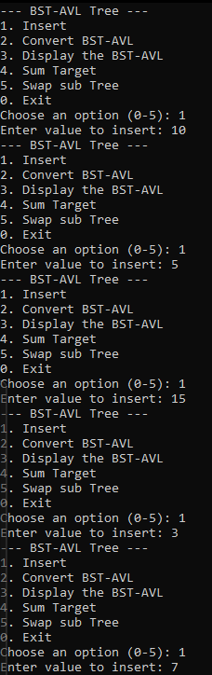
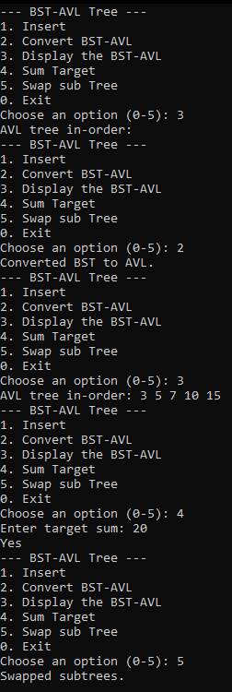
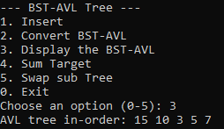
Task 3
Problem
#include <iostream>
#include <string>
using namespace std;

struct Node {
string username;
int timestamp;
Node* left;
Node* right;
int height;

Node(string user, int time) : username(user), timestamp(time), left(nullptr), right(nullptr), height(1) {}
};

int max(int a, int b) {
if (a > b) {
return a;
}
else {
return b;
}
}

int height(Node* node) {
if (node == nullptr) {
return 0;
}
return node->height;
}

int balanceFactor(Node* node) {
if (node == nullptr) {
return 0;
}
return height(node->left) - height(node->right);
}

void updateHeight(Node* node) {
if (node)
node->height = 1 + max(height(node->left), height(node->right));
}

Node* rightRotate(Node* y) {
Node* x = y->left;
Node* temp = x->right;
x->right = y;
y->left = temp;
updateHeight(y);
updateHeight(x);
return x;
}

Node* leftRotate(Node* x) {
Node* y = x->right;
Node* temp = y->left;
y->left = x;
x->right = temp;
updateHeight(x);
updateHeight(y);
return y;
}

Node* insertOrUpdate(Node* node, string username, int timestamp) {
if (!node)
return new Node(username, timestamp);

if (username < node->username)
node->left = insertOrUpdate(node->left, username, timestamp);
else if (username > node->username)
node->right = insertOrUpdate(node->right, username, timestamp);
else {
node->timestamp = timestamp;
return node;
}

updateHeight(node);
int balance = balanceFactor(node);

if (balance > 1 && username < node->left->username)
return rightRotate(node);

if (balance < -1 && username > node->right->username)
return leftRotate(node);

if (balance > 1 && username > node->left->username) {
node->left = leftRotate(node->left);
return rightRotate(node);
}

if (balance < -1 && username < node->right->username) {
node->right = rightRotate(node->right);
return leftRotate(node);
}

return node;
}

void rangeQuery(Node* node, int startTime, int endTime) {
if (!node) return;

if (node->timestamp >= startTime)
rangeQuery(node->left, startTime, endTime);

if (node->timestamp >= startTime && node->timestamp <= endTime)
cout << node->username << " ";

if (node->timestamp <= endTime)
rangeQuery(node->right, startTime, endTime);
}

void printInOrder(Node* node) {
if (!node) return;
printInOrder(node->left);
cout << node->username << " (" << node->timestamp << ") ";
printInOrder(node->right);
}

void displayMenu() {
cout << "--- Instagram login count menu ---" << endl;
cout << "1. Insert/Update User" << endl;
cout << "2. Query Users by Time Range" << endl;
cout << "3. Display All Users" << endl;
cout << "0. Exit" << endl;
}

int main() {
Node* root = nullptr;
int choice, timestamp, startTime, endTime;
string username;

while (true) {
displayMenu();
cout << "Choose an option (0-3): ";
cin >> choice;

switch (choice) {
case 1:
cout << "Enter username: ";
cin >> username;
cout << "Enter timestamp: ";
cin >> timestamp;
root = insertOrUpdate(root, username, timestamp);
break;

case 2:
cout << "Enter start time: ";
cin >> startTime;
cout << "Enter end time: ";
cin >> endTime;
cout << "Users who logged in between " << startTime << " and " << endTime << ":\n";
rangeQuery(root, startTime, endTime);
cout << endl;
break;

case 3:
cout << "All users (in-order): ";
printInOrder(root);
cout << endl;
break;

case 0:
cout << "Exiting..." << endl;
return 0;

default:
cout << "Invalid option. Please try again." << endl;
}
}

system("pause");
return 0;
}
Screenshot
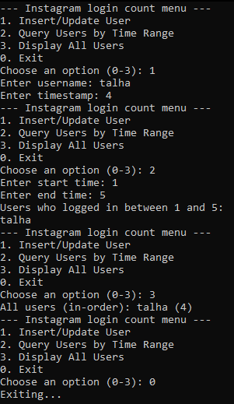
Task 4
Problem
#include <iostream>
using namespace std;

struct Node {
int value;
Node* left;
Node* right;
int height;

Node(int val) : value(val), left(nullptr), right(nullptr), height(1) {}
};

int max(int a, int b) {
return (a > b) ? a : b;
}

int height(Node* node) {
return node ? node->height : 0;
}

int balanceFactor(Node* node) {
return node ? height(node->left) - height(node->right) : 0;
}

void updateHeight(Node* node) {
if (node) {
node->height = 1 + max(height(node->left), height(node->right));
}
}

Node* rightRotate(Node* y) {
Node* x = y->left;
Node* T2 = x->right;

x->right = y;
y->left = T2;

updateHeight(y);
updateHeight(x);

return x;
}

Node* leftRotate(Node* x) {
Node* y = x->right;
Node* T2 = y->left;

y->left = x;
x->right = T2;

updateHeight(x);
updateHeight(y);

return y;
}

Node* insert(Node* node, int value) {
if (!node) return new Node(value);

if (value < node->value)
node->left = insert(node->left, value);
else if (value > node->value)
node->right = insert(node->right, value);
else
return node;

updateHeight(node);
int balance = balanceFactor(node);

if (balance > 1 && value < node->left->value)
return rightRotate(node);

if (balance < -1 && value > node->right->value)
return leftRotate(node);

if (balance > 1 && value > node->left->value) {
node->left = leftRotate(node->left);
return rightRotate(node);
}

if (balance < -1 && value < node->right->value) {
node->right = rightRotate(node->right);
return leftRotate(node);
}

return node;
}

Node* findMax(Node* node) {
while (node->right) {
node = node->right;
}
return node;
}

Node* join(Node* T1, Node* T2) {
if (!T1) return T2;
if (!T2) return T1;

Node* maxNode = findMax(T1);
maxNode->right = T2;

updateHeight(maxNode);
int balance = balanceFactor(T1);

if (balance > 1 && balanceFactor(T1->left) >= 0) {
return rightRotate(T1);
}
if (balance < -1 && balanceFactor(T1->right) <= 0) {
return leftRotate(T1);
}
if (balance > 1 && balanceFactor(T1->left) < 0) {
T1->left = leftRotate(T1->left);
return rightRotate(T1);
}
if (balance < -1 && balanceFactor(T1->right) > 0) {
T1->right = rightRotate(T1->right);
return leftRotate(T1);
}

return T1;
}

void printInOrder(Node* node) {
if (!node) return;
printInOrder(node->left);
cout << node->value << " ";
printInOrder(node->right);
}

void displayMenu() {
cout << "--- AVL Tree Operations ---" << endl;
cout << "1. Insert into T1" << endl;
cout << "2. Insert into T2" << endl;
cout << "3. Join T1 and T2" << endl;
cout << "4. Display joined AVL tree (in-order)" << endl;
cout << "0. Exit" << endl;
}

int main() {
Node* T1 = nullptr;
Node* T2 = nullptr;
Node* joinedTree = nullptr;

int choice, value;
while (true) {
displayMenu();
cout << "Choose an option (0-4): ";
cin >> choice;

switch (choice) {
case 1:
cout << "Enter value to insert into T1: ";
cin >> value;
T1 = insert(T1, value);
cout << "Inserted " << value << " into T1." << endl;
break;

case 2:
cout << "Enter value to insert into T2: ";
cin >> value;
T2 = insert(T2, value);
cout << "Inserted " << value << " into T2." << endl;
break;

case 3:
joinedTree = join(T1, T2);
cout << "Joined T1 and T2 into a single AVL tree." << endl;
break;

case 4:
if (joinedTree) {
cout << "In-order traversal of the joined AVL tree: ";
printInOrder(joinedTree);
cout << endl;
}
else {
cout << "The AVL tree has not been joined yet." << endl;
}
break;

case 0:
cout << "Exiting..." << endl;
return 0;

default:
cout << "Invalid option. Please try again." << endl;
}
}

return 0;
}
Screenshot
